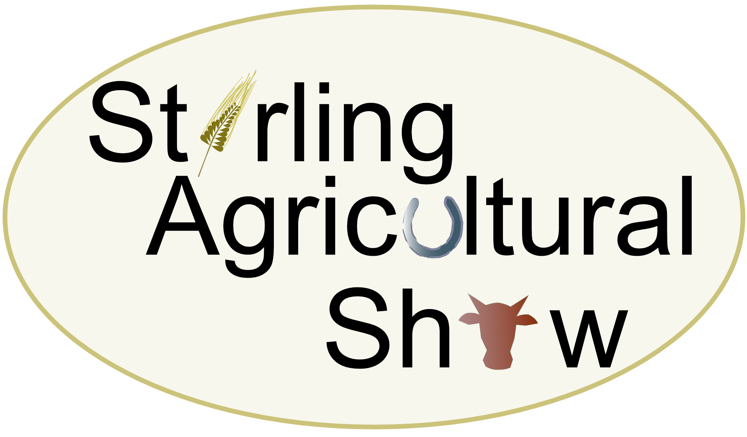

LIVESTOCK ENTRY FORM
Saturday 14th June 2025

Entry Fees: | Cattle | £10.00 per entry
 | Sheep | £5.00 per entry
 | Clydesdale Horses | £10.00 per entry

(All exhibitors are subject to a £2 First Aid charge)
CATALOGUE ENTRIES CLOSE: Monday 2nd June 2025

RETURN ENTRIES to: Jen Kinnear, 6 Menzies Avenue, Fintry, Glasgow, G63 0YE
07798 895931
SECTION | CLASS  NUMBER | NUMBER IN  CLASS | ENTRY  FEE
 |  | Cost of entry | £
 |  | Membership | £ 8.00
 |  | First-Aid fee | £ 2.00
 |  | TOTAL  ENCLOSED | £

Name: ……………………………………………… Email Address: ……………………………………….……..
Address: ……………………………………………………………………………………………………………………
Post Code: ……………………………………… Tel No: …………………………………………………………..
PLEASE INDICATE:
CATTLE: Passport’s must be brought to the show
SHEEP: M.V. Accredited/ Non Accredited
Scrapie Approved: See Rules & Regulations and please sign Entry Form
( MVAS) health status report SIGNED to be shown before unloading at the show)

